

Award nominations for outstanding young people in construction

The Construction Development Alliance (“CDA”) is pleased to take nominations for the 2016 CDA Awards which will recognise up to five outstanding young people between the ages of 16 and 25 who exemplify the best attributes of the North West’s young construction folk. Nominations are invited for each of the five categories listed overleaf. There will be a trophy and a small prize, plus the opportunity to be considered as the overall winner and a substantial prize.

The 2016 awards are sponsored by SIKA and the CDA will be presented by Dominic Littlewood on the 26st May 2016, to be held at Burnley Mechanics Theatre



For details about the 2014 CDA winners please go to:

http://www.cdalliance.co.uk/2014-cda-awards-hosted-by-george-clark1.html

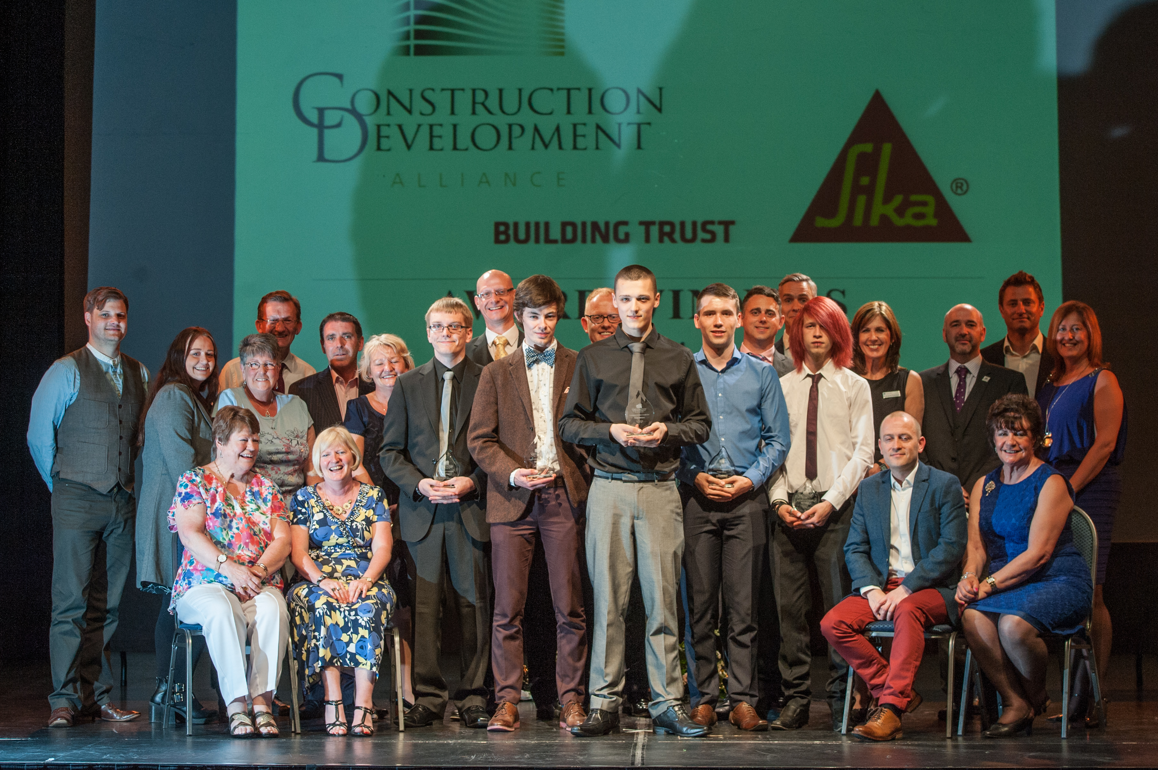

Burnley Mechanics CDA 2014 winners

There will also be a charity raffle and any proceeds raised on the night will be donated to our nominated Charity.

The ceremony will highlight each winner’s career or training so far and provide a stage from which the winners can inspire others. Following each award announcement, the winner will have the opportunity to give a short acceptance speech.

Winners will be selected by a panel of judges made up from the CDA members whom are all construction related professionals.

APPLICATION INSTRUCTIONS:

After entering the information below, answer each of the four questions on the following page and additional sheets. Guidance on the size of the answers is set out below. Number each answer to correspond with the question. Please be as detailed as possible. When answering the questions, keep in mind the category in which you are entering the nominee.

NOMINEE’S FULL NAME:

UK CITIZEN / PERMANENT RESIDENT Y/N

DATE OF BIRTH:

PRESENT AGE:

HOME ADDRESS:

TELEPHONE:

MOBILE PHONE:

EMAIL ADDRESS:

OCCUPATION/ PROFESSION/

STUDENT:

ORGANISATION NAME :

ORGANISATION ADDRESS:

WORK TELEPHONE:

WORK FAX:
AWARD CATEGORY | 1. Overcoming adversity in construction,  2. Young designer of the year,  3. Young apprentice in construction,  4. Young construction professional,  5. Young construction environmentalist
DEADLINE: SUBMIT NO LATER THAN 26th April 2016

- OUTLINE THE CAREER OR TRAINING OF THE NOMINEE, INCLUDING BACKGROUND OF THE NOMINEE’S WORK OR FIELD OR ACTIVITY.
- PROVIDE INFORMATION WHICH WILL HELP THE JUDGES UNDERSTAND THE CHALLENGES, PROBLEMS, AND SCOPE OF THE NOMINEE’S AREA OF ACTIVITY.
- DESCRIBE THE NOMINEE’S EXCEPTIONAL ACHIEVEMENTS OR CONTRIBUTIONS IN HIS/HER CHOSEN FIELD.
- LIST PUBLIC STATEMENTS FROM EMPLOYERS, COLLAGE LECTURERS, EXTERNAL BODIES/AUTHORITIES, AND AWARDS RECEIVED, WHICH AFFIRM THE NOMINEE’S ACHIEVEMENTS AND CONTRIBUTIONS.
Note: all answers to 1 to 4 must be no more than 2 A4 in total.

FOR NOMINATOR:

Summarise within this space why you believe that the nominee should be selected as a CDA Award Winner for 2016. Please type below but no more than 1 A4 page.

SIGNATURE: | ……………………………………………………………………………..
NAME OF NOMINATOR:
ADDRESS:
TELEPHONE (WORK):
TELEPHONE (HOME / MOBILE):
EMAIL ADDRESS:
OCCUPATION OR BUSINESS:

FOR NOMINEE:

I attest to all facts contained in this form and give permission for the facts and images to be used for publication. In agreeing to accept an Award, I understand that, barring extreme circumstances, I am required to attend any photography/PR events prior to the main event and the CDA Awards Evening on 26th May 2016. In the event that circumstances prevent my attendance, I must present the conditions to the Chairman of the CDA for a decision on the continued eligibility of my nomination.

SIGNATURE: | ……………………………………………………………………………………
DATE:

Either directly or through the respective Nominator, the CDA will notify all selected finalists by the end of April 2016.
For entry forms please e-mail c.pessagno@pooledick.co.uk or request an application by post from Catherine Pessagno, Poole Dick Associates, Waterfold Park, Bury BL9 7BR.
It is important that both the electronic copy or hard copy are delivered by the closing date of 26th April 2016.

RULES GOVERNING NOMINATIONS:

1. Nominees must be between 16 and 25 years of age.

2. The nominee must be a British Citizen or a Permanent UK Resident.

3. The nominee must sign the official nomination form attesting to all facts contained in the form and granting permission for publication of these facts and images. By signing this form, the nominee also indicates willingness, barring extreme circumstances, to attend the Construction Development Alliance (“CDA”) Awards Ceremony fixed for 26th May 2016, if short-listed as a finalist for any of the awards.

4. The nominee will attend a PR photo shoot in May 2016.

- All information must be contained on the pages of this official form.

6. A photograph must be submitted with the official nomination form.

7. The nominee must be entered in one of the five categories listed on this form. Please note: Each nominee may be nominated in only one category per form. The Judges have the right to transfer the nominated candidate to a more suitable category.

8. Nomination forms must be submitted by 26th April 2016. Please post/deliver completed forms to the address stated on the last page of the nomination form. An email address must be provided. All nomination forms will be acknowledged by email. If the forms are delivered after the 26th April 2016, the application may not be accepted.

1. Overcoming adversity in construction,

CRITERIA:

Someone who has achieved success in college or at work, either through their position, determination, exam success, career progression, leadership, deals negotiated or financial results despite overcoming some form of adversity.

2. Young designer of the year,

CRITERIA:

Someone who has achieved success in design either at college or at work, in any form of design associated with the construction industry for example architectural, interior design, mechanical, electrical, structural, landscape etc.

3. Young apprentice in construction,

CRITERIA:

An apprentice working in a construction related profession who has achieved success and or been recognised by others as being an outstanding candidate in what they have achieved in their role as an apprentice.

4. Young construction professional,

CRITERIA:

Someone who has demonstrated exceptional performance of their duties either at college or working in their specific field. The candidate must promote leadership skills, inspire and encourage others. A positive “can do” attitude and a willingness and desire to continue to learn, develop and become better in their chosen field. Candidates are invited from individuals in all sectors. We will be looking for success in college and or at work, with evidence of career progression, leadership skills, creating a project and making it happen, inspiring and motivating others to make it happen, good negotiation skills or even financial results. The successful person will be a role model, who has clear values and has made a sustained difference this year.

5. Young construction environmentalist

CRITERIA:

Someone who has achieved success in a construction related profession or college course that has an environmental element to a project and has made a significant contribution towards protecting and improving the environment. This may include (but is not limited to) organising an environmentally friendly project, undertaking and developing energy saving initiatives, or generating awareness about climate change or other environmental issues. The candidate should be someone who has organised a program, project or activity for the benefit of a community and engaged, inspired and motivated people or public bodies to get involved in the particular charitable or social cause. We will be looking for someone who has made an environmental difference this year.

CDA
Mar 2016

